Toy Factory Unit
Magnetism and Electromagnets

- magnetisim- a force that pushes and pulls certain metals. 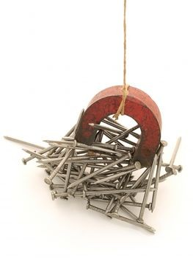
- magnet- an object that attracts certain metals. It is most attracted to iron.
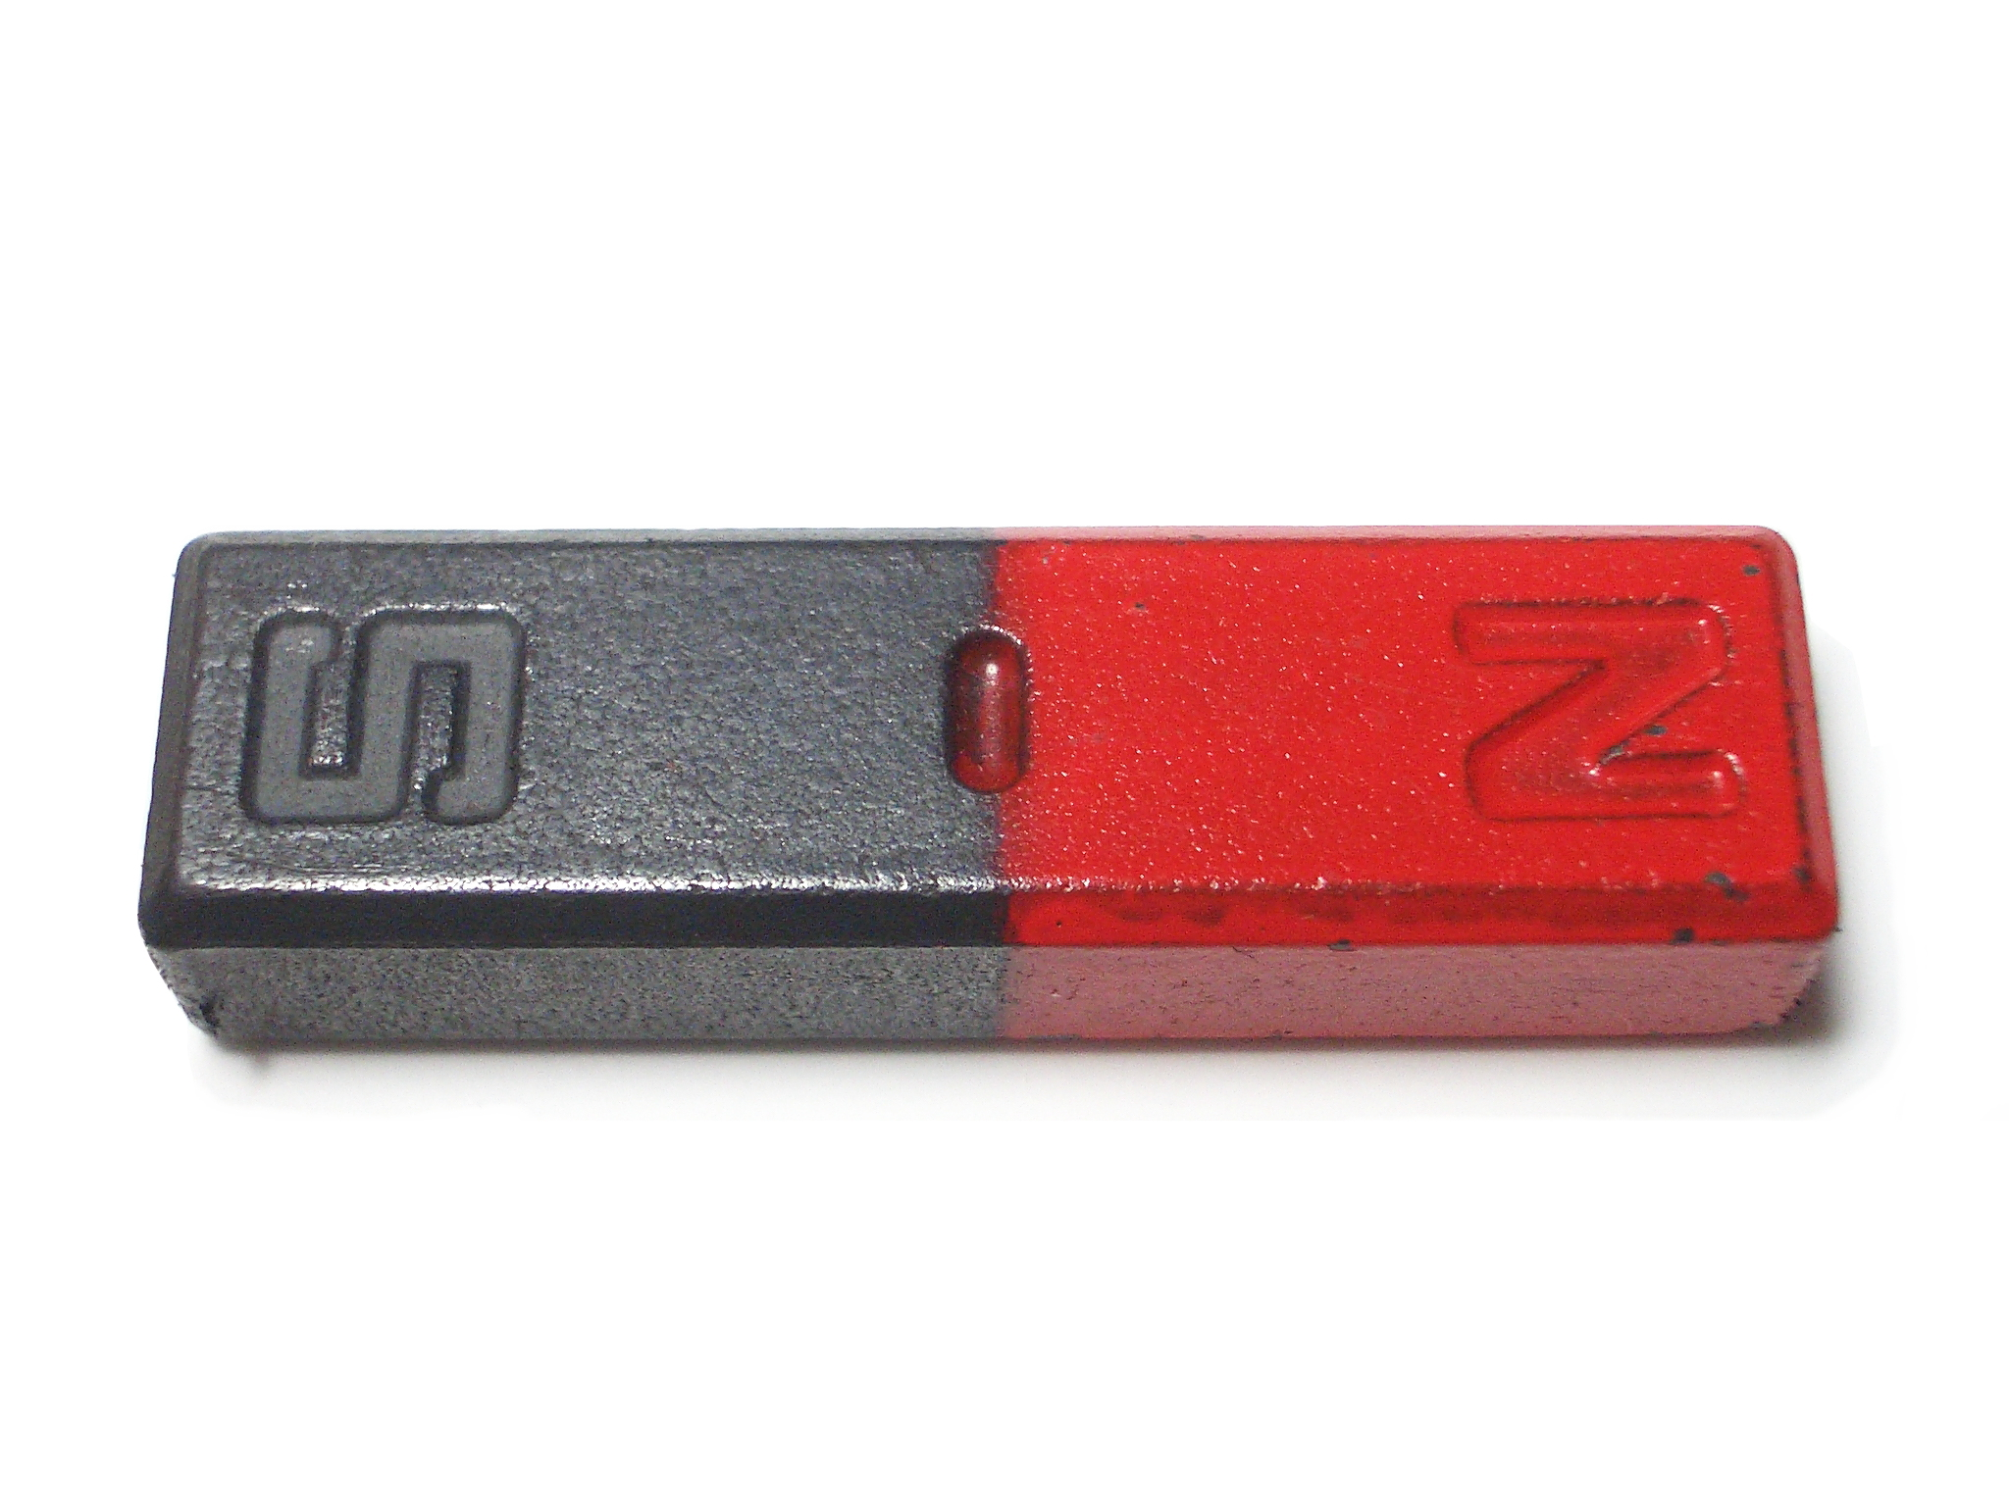

- attract- to pull something closer

- repel- to push something away

- magnetic poles- Two areas where the force of a magnet are at its greatest.
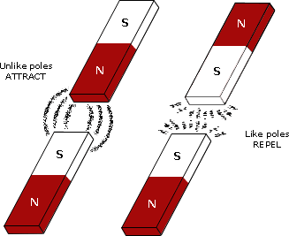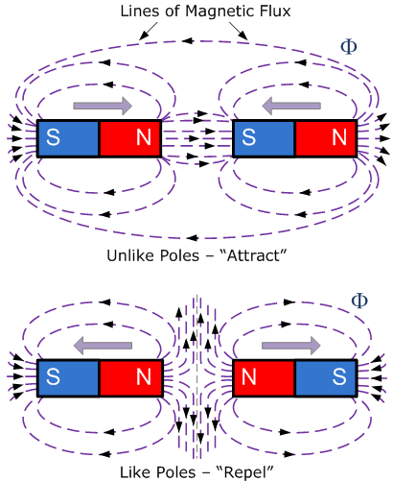

- magnetic field- an area around a magnet where magnetic force can be felt.
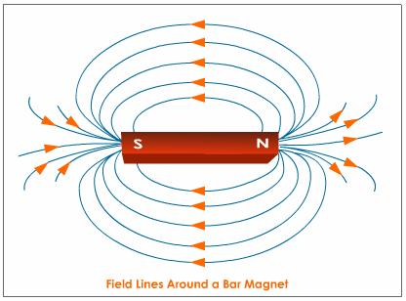

- electromagnet-A strong temporary magnet that uses electricity to produce magnetism.
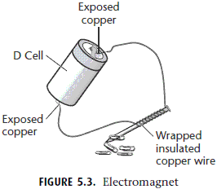
- generator-A device that uses magnetism to convert the energy of motion into electrical energy.

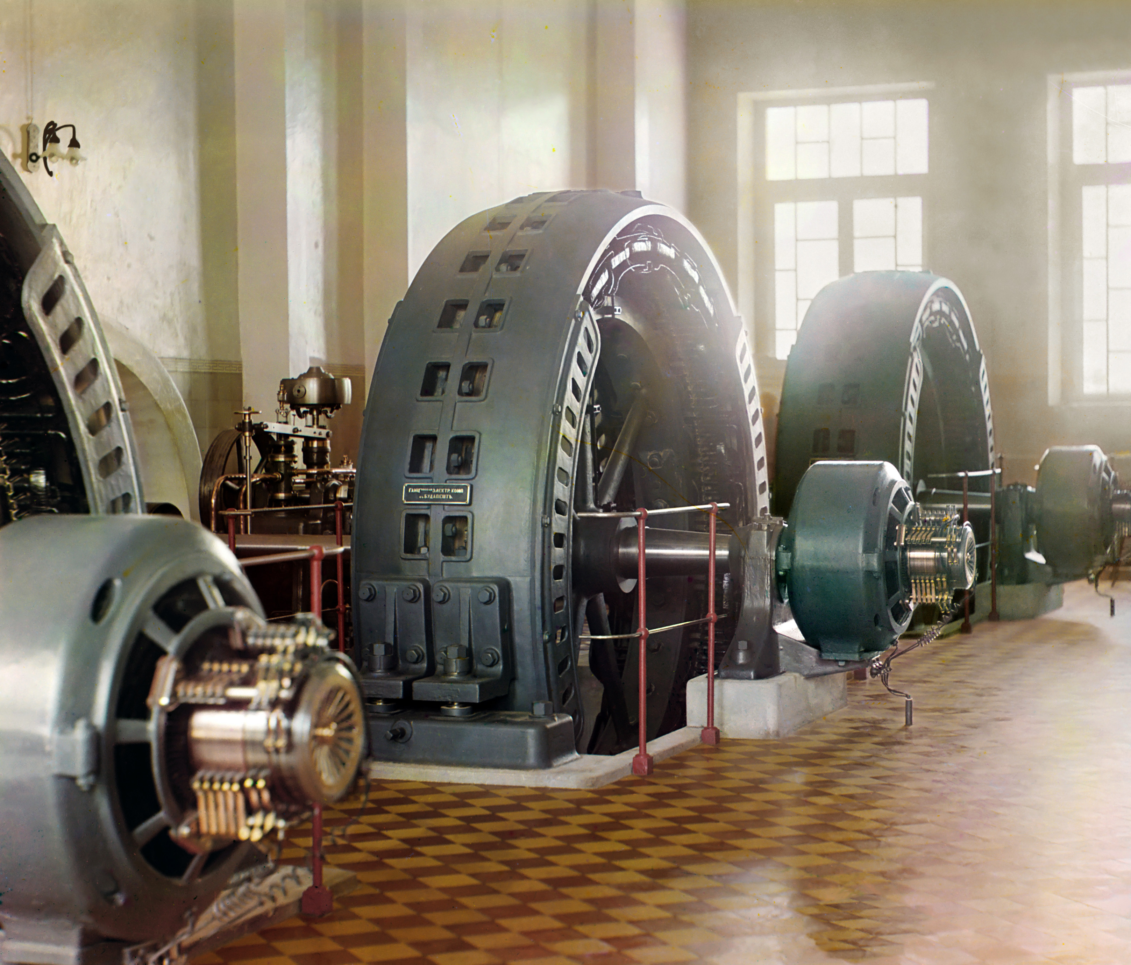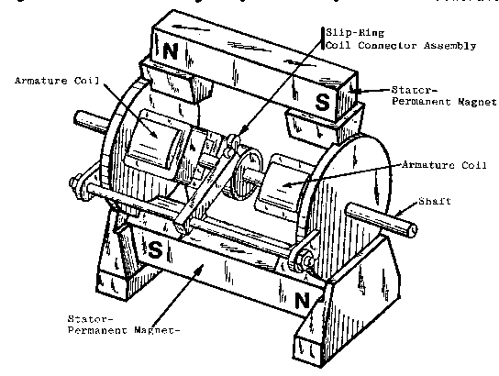

- permanent magnet- An object that keeps its magnetism for a long time.
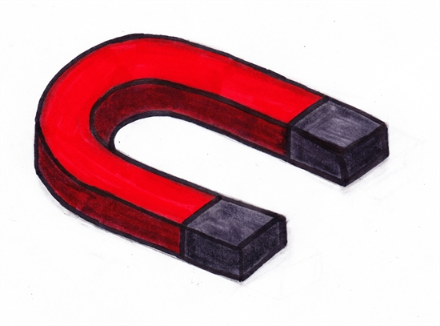

- temporary magnet- An object that loses its magnetism after a short time.
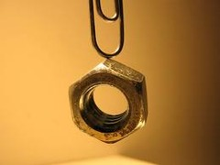
- compass – An instrument that senses magnetic north using a free-moving magnet.

