Toy Factory Unit
Electricity

- Electricity- A form of energy produced by the movement of electrons. It can be used to make heat, light and can power machines.

- Battery- A source of electrical energy. A device that converts chemical energy to electrical energy.

- Conductor- A material that allows electrical current to flow through it.

  - Metals like copper, aluminum, gold and silver are good conductors.

- Insulator- Insulators are opposite of conductors. A material that electric charges do not flow through easily.

  - Wood, air, rubber, and glass are insulators.

5. Diagram- A picture that shows how something works – an explanatory drawing or plan.
- Parallel Circuit- A kind of circuit in which there is more than on path an electric current can flow through.

- Series Circuit: A kind of circuit in which there is only one path that an electric current can flow through.

- Electric Current- The flow of electricity through a conductor from one place to another.

- Switch-A device that opens or closes a circuit. This prevents or allows a current to flow.

Static Electricity | Current Electricity
- a build up of electrons | - the steady flow of electrons between objects or places.
- stays in one place until it jumps to an object | - needs a conductor, a material that allows electrons to move easily through it
- does not need a circuit | - needs a closed circuit to flow
- the kind of electricity you feel after you drag your feet across a carpet and touch someone or something | - the kind of electricity that powers the appliances and heat in your home
- lightning is static electricity on a more spectacular scale | - the kind of electricity in a battery

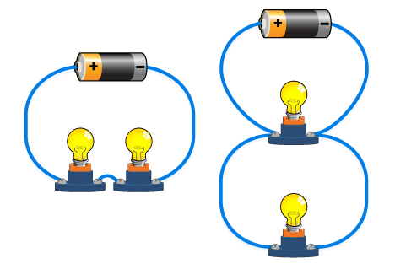

Example of a insulator and conductor in a chord. 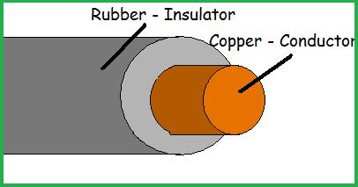

Diagram of Electrical Circuit

