Name:_________
Get Deep With Alvin

Questions 1-7 go to http://www.whoi.edu/alvin/.

Title of Article: _________________________

Name of Website: ______________________

- What is the Submersible’s name? _________________________

- How many dives has the Alvin made?___________________________________________________________________________________________________

- What are two famous things Alvin has seen in the deep oceans?

- _____________________________________________
- ____________________________________________

- How many people can ride in Alvin for a dive? Who are they?
____________________________________________________________________________________________________________________________________________________________

- How long does each dive last? ________________________________________________________________________________________________________

- Why is Alvin disassembled every three to five years? ____________________________________________________________________________________________________________________________________________________________

- Why is the sub named Alvin? ________________________________________________________________________________________________________
--------------------------------------------------------------------------------------

Questions 8-10 Go to Special Multimedia Feature
on the right side and click on Vehicle Tour. O

Briefly describe what each part of the diagram does. Then circle where it would be on the diagram below.

8. Sample Basket: _________________________________________

9. Sail: _________________________________________________

10. Thrusters: ___________________________________________

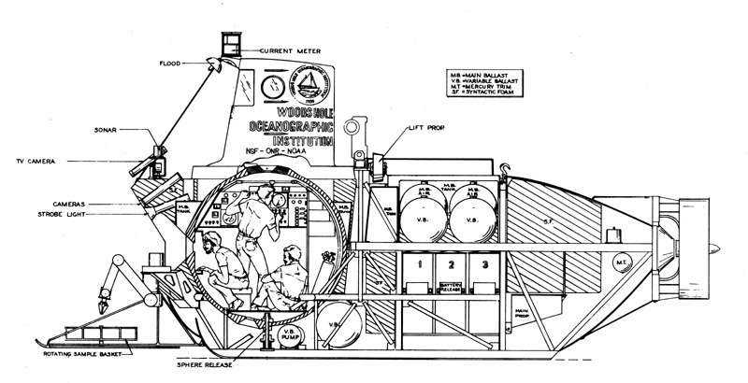

--------------------------------------------------------------------------------------

Question 9: Click In The Field on the right side and watch the video.

After watching this video, would you want to be on a submersible crew. Please explain why or why not with 3 examples. Use complete sentences.

_________________________________________________________

