Name: ____________________

How We Organize Ourselves
Mission Unit Vocabulary

1. Economy: The wealth and resources of a country or a region, especially in terms of the producing and consuming (making and using) of goods and services.

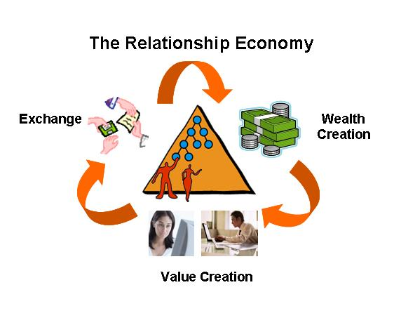
2. Sustainable: able to be maintained or to last

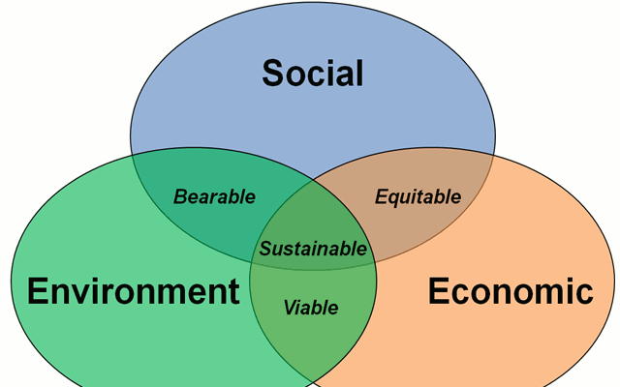

3. Equality: The state of being equal, especially in rights, status and opportunity.

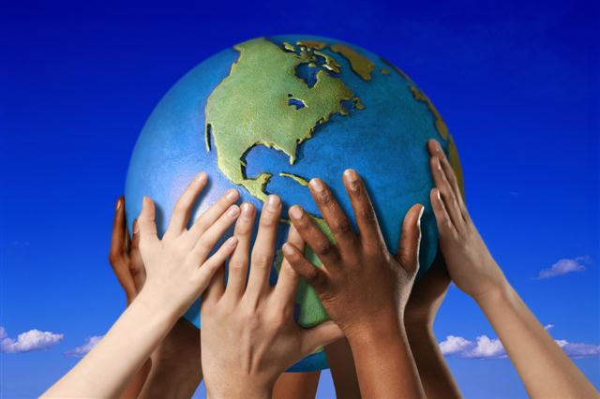

4. Environment: The surroundings or conditions in which a person, animal, or plant lives.

5. Perspective: A particular attitude toward or a point of view.

6. Interconnected: to be connected together

7. Architect: Someone who designs and plans the construction of buildings or other large structures.

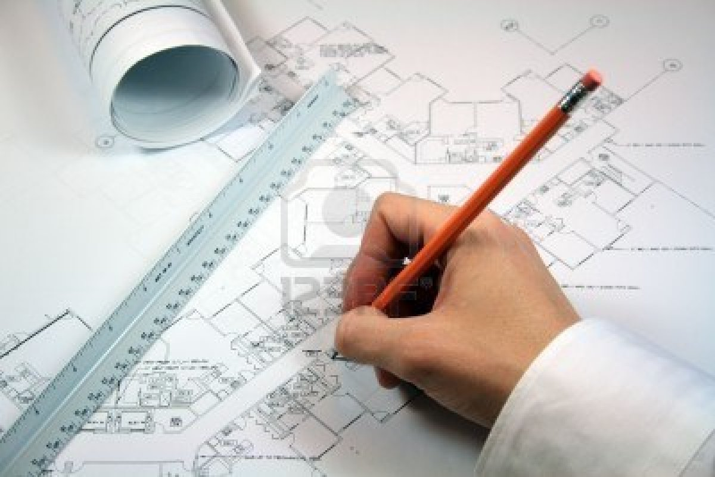

8. Structure: Something constructed, such as a building.

9. Adobe: A compound made of natural clay, straw, and sometimes dung. The mixture was usually pressed into molds and then baked in the sun to form durable bricks.

10. Mission: A religious settlement or community where people lived worked and practiced Catholicism.

